Call to a primitive / primitive call

* It starts with an open parenthesis and then the name of a primitive operation

Parts of a primitive call

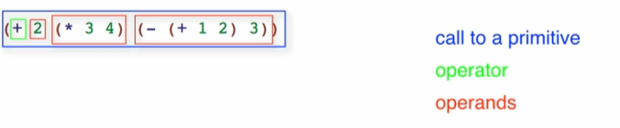

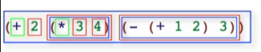

To evaluate a primitive call

* First reduce operands to values
* Then apply primitive to the values

Step by step:

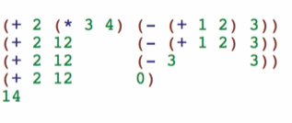

Intuitively

* Left to right
* Inside to outside